Documentation

CSCI_6461_12: Project P1

Group 10:

Alekya Kowta

Nikhil Arethiya

Peiyan Liu

Aryan Saxena

Overview and Purpose

Part II extends the Part I simulator with a unified, fully associative cache, broader instruction coverage (all except Part IV items), and the ability to run Program 1 (read 20 integers, print them, accept a target, print the closest number). We also expanded the UI to visualize cache lines and basic statistics (hits/misses).

GitHub Repository Link
https://github.com/AlekyaKowta/CSCI_6461_FALL25_PROJECT-TEAM-10

Installation and Usage
Installation:
• Ensure the target system has Java Runtime Environment (JRE) version 8 or higher installed.
• Download or obtain the packaged cs6461-simulator.jar file.
• Place your Program 1 machine code file (e.g., LOADFILE.txt) in the same directory as the JAR.
Usage:
- Open a terminal or command prompt.
- Navigate to the directory containing Simulator.jar and LoadFile.txt.
- Run the assembler with the command:

• Load Program: Click the IPL button and select your load file.
• Execute: Use Step for instruction-by-instruction execution or Run to execute continuously.
- When asked for input give all the 20 numbers with space between them:
Example: -50 -25 -10 -5 -1 0 1 2 3 4 5 10 25 50 100 200 300 400 500 1000
- Then when prompted for another input, input the target: say 30
- Output will be printed in “Console Output”
• Observe results in the Printer area and cache visualization on the right panel.

Folders
Folder | Contents

assembler/ | Assembler and Opcode Tables from Project 1

core/ | MachineController, MachineState

core/cache/ | Cache implementation for Part II

ui/ | SimulatorUI (front panel and visualization)

Documentation/ | Project documents and design notes

User Interface and Cache Visualization
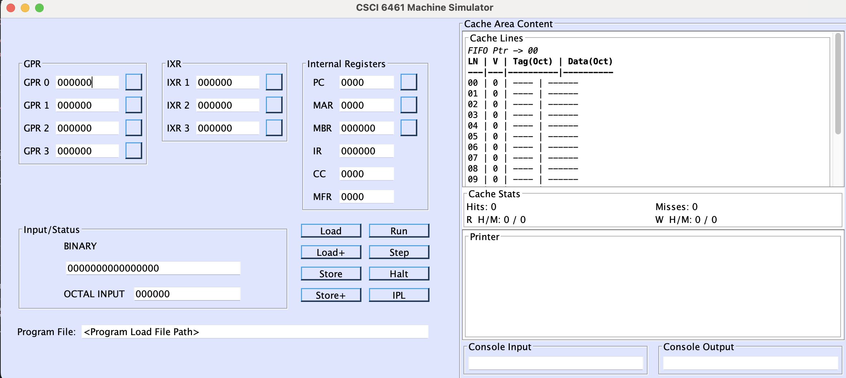

The simulator’s Swing-based front panel provides complete visibility of machine registers, memory, and cache state.

Register Display
- GPR0–GPR3, IX1–IX3: 16-bit registers displayed as 6-digit octal values.
- PC, MAR: 12-bit registers displayed as 4-digit octal values.
- CC, MFR: 4-bit registers displayed as 4-digit octal values.

Cache Panel
- Displays 16 cache lines (fully associative) in a monospaced grid.
- Recent access is highlighted: green for hit, red for miss.
- FIFO pointer and detailed hit/miss statistics displayed below.

Input Specification
The simulator accepts a machine code load file generated by the assembler.
The simulator requires a Load File as input, which is the direct numerical output from the two-pass assembler. This file defines the memory addresses and their contents.
During runtime, the user inputs 20 integers followed by a target number through the Console Input field in the UI.

Output Specification
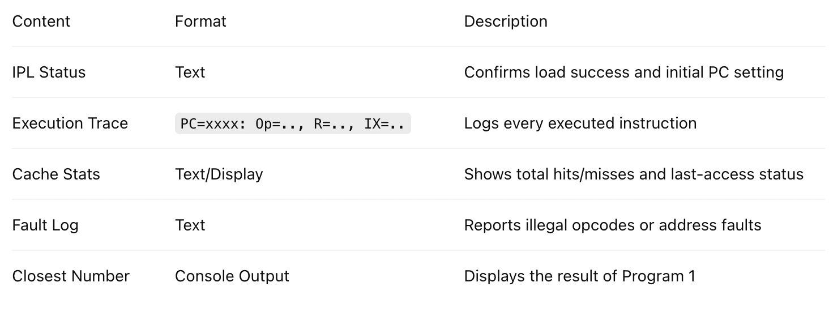

Design and Structure

Key Architectural Components
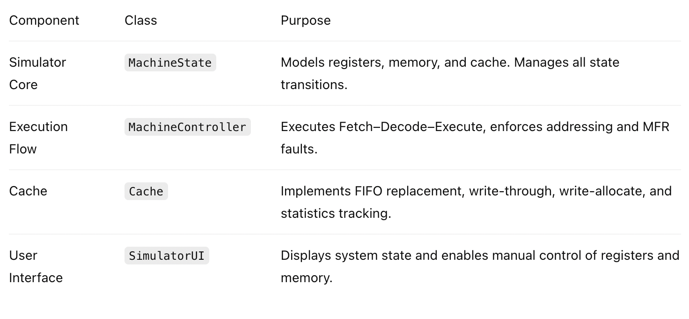

Execution Controls

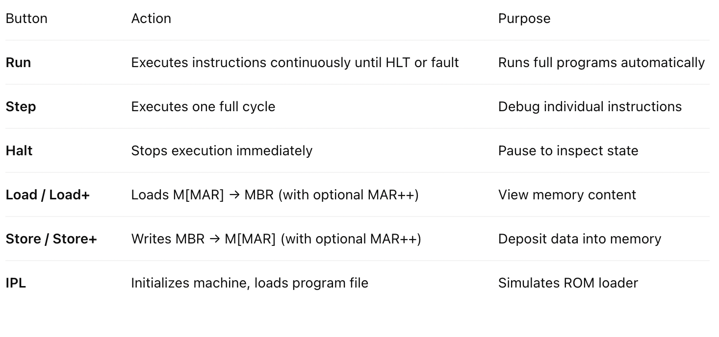

Error Handling
• Illegal Opcode: Sets MFR and halts.
• Address Out of Range: Guarded in EA computation; halts with MFR flag.
• Undefined Device: Logs warning in printer area.
• IPL Errors: Displayed clearly with no state modification.

Extensibility
• Modular instruction handlers allow new operations without major refactoring.
• Cache system easily configurable for LRU or write-back in future phases.
• UI expandable for floating-point/vector extensions in Part IV.

Limitations
• TRAP, Floating Point, and Vector instructions unimplemented (reserved for Part IV).
• Condition Code updates simplified for certain arithmetic operations.
• No true asynchronous I/O or interrupt handling.

Testing
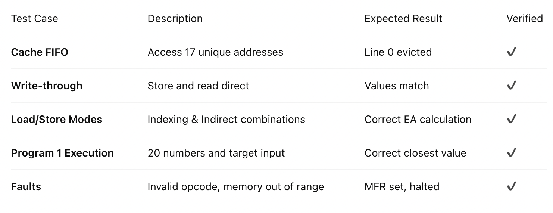

Test Cases for Program 1:

Test Case 1
Input (20 Integers):
10 20 30 40 50 60 70 80 90 100 110 120 130 140 150 160 170 180 190 200
Target: 75
Expected Output (Closest Number): 70

Test Case 2
Input (20 Integers):
-200 -180 -160 -140 -120 -100 -80 -60 -40 -20 20 40 60 80 100 120 140 160 180 200
Target: -90
Expected Output (Closest Number): -80

Test Case 3
Input (20 Integers):
-10 -12 -14 -16 -18 -20 -22 -24 -26 -28 -30 -32 -34 -36 -38 -40 -42 -44 -46 -48
Target: -33
Expected Output (Closest Number): -32

Test Case 4
-99 -88 -77 -66 -55 -44 -33 -22 -11 11 22 33 44 55 66 77 88 99 111 122
Target: -10
Expected Output (Closest Number): -11

Test Case 5
Input (20 Integers):
-200 -150 -120 -100 -90 -80 -70 -60 -50 -40 -30 -20 20 40 60 80 100 120 150 200
Target: 90
Expected Output (Closest Number): 100

Test Case 6
Input (20 Integers):
-999 -900 -800 -700 -600 -500 -400 -300 -200 -100 100 200 300 400 500 600 700 800 900 999
Target: -450
Expected Output (Closest Number): -400

Test Case 7
Input (20 Integers):
-210 -190 -170 -150 -130 -110 -90 -70 -50 -30 -10 10 30 50 70 90 110 130 150 170
Target: 175
Expected Output (Closest Number): 170

Test Case 8
Input (20 Integers): -32768 32767 0 1 -1 100 -100 256 -256 4095 -4095 7 -7 13 -13 42 -42 1000 -1000 2
Target: 32700
Expected Output (Closest Number): 32767

Test Case 9
Input (20 Integers):
-32768 -30000 -25000 -20000 -15000 -10000 -5000 -2000 -1000 -500 500 1000 2000 5000 10000 15000 20000 25000 30000 32767
Target: 31000
Expected Output (Closest Number): 30000

Test Case 10
Input (20 Integers):
-200 -180 -160 -140 -120 -100 -80 -60 -40 -20 20 40 60 80 100 120 140 160 180 200
Target: 145
Expected Output (Closest Number): 140

Test Case 11
Input (20 Integers):
-42 -42 -42 -42 -42 -42 -42 -42 -42 -42 -42 -42 -42 -42 -42 -42 -42 -42 -42 -42
Target: -100
Expected Output (Closest Number): -42

Test Case 12
Input (20 Integers):
10 20 30 40 50 60 70 80 90 100 15 25 35 45 55 65 75 85 95 105
Target: 36
Expected Output (Closest Number): 35

Test Case 13
Input (20 Integers):
-5000 -2500 -1000 -900 -800 -700 -600 -500 -400 -300 -200 -100 100 200 300 400 500 1000 2500 5000
Target: -750
Expected Output (Closest Number): -800

Test Case 14
Input (20 Integers):
60 100 40 1000 50 999 70 998 80 997 90 996 100 995 110 994 120 993 130 992
Target: 55
Expected Output (Closest Number): 60

Test Case 15
Input (20 Integers):
-140 -121 -250 -300 -110 -102 -98 -88 -76 -64 -52 -40 -28 -16 -128 -512 -1024 -2048 2048 4096
Target: -120
Expected Output (Closest Number): -121

References
- Instruction Set Architecture Specification Document
- Java Development Kit Documentation
- Related Academic Publications on Assembly Language Programming

